Case No. 2017-001
DEPARTMENT OF TRANSPORTATION

REQUEST FOR SERVICE
SPECIAL PUBLIC HEARING NOTICE

FROM: Michael Russell TELEPHONE NO: 704-353-0225

E-Mail: mrussell@charlottenc.gov

DEPARTMENT: Planning DATE: 11-21-2016

TYPE HEARING

REZONING

LOCATION (ONLY ONE LOCATION PER REQUEST): SEE ATTACHMENTS

DATE SIGNS NEED TO BE INSTALLED: 12-9-2016 ; REMOVED: TBA

NUMBER OF SIGNS REQUIRED: 1_

Note: Request MUST be RECEIVED by Traffic Operations Division/CDOT a MINIMUM of ten (10) working days PRIOR to date signs must be installed.

Site location description:

Approximately 11.9 acres located on the south side of Spector Drive near the intersection of Statesville Road and Spector Drive.

Tax Parcel(s): 03719214

Place 1 rezoning sign on the south side of Spector Drive to the right of the driveway on utility pole.
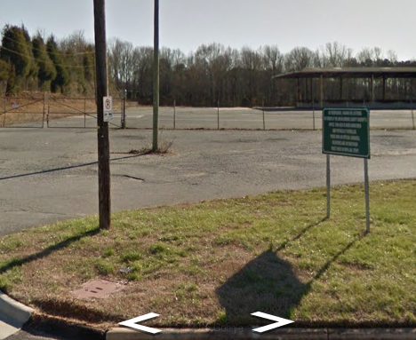

Place rezoning sign(s) as stated above and indicated below by the red dot(s).
