Staff Analysis Consistency - Land Use and Public Policies
Reviewer Name: Alberto Gonzalez
Case #: 2015-026
Current and Proposed Zoning: R-5, Residential Single-Family to; UR-2(CD), Urban Residential, Conditional

Location: McClintock Road and St. Julien Street
Review based on site plan dated: December 19, 2014
Summary of Petition/Proposed Land Use
- To allow the development of 12 single family units.

Current Adopted Land Use Policy and GDP (if applicable)
- The Central District Plan (1993) adopted land use for this site is single-family up to 4DUA, as well as office for one of the parcels on McClintock Rd. (2145 McClintock Rd.).

- The petition meets the General Development Policies (GDP) for the density requested, as illustrated in the table below (Design points however, are contingent on the site plan meeting the design guidelines):

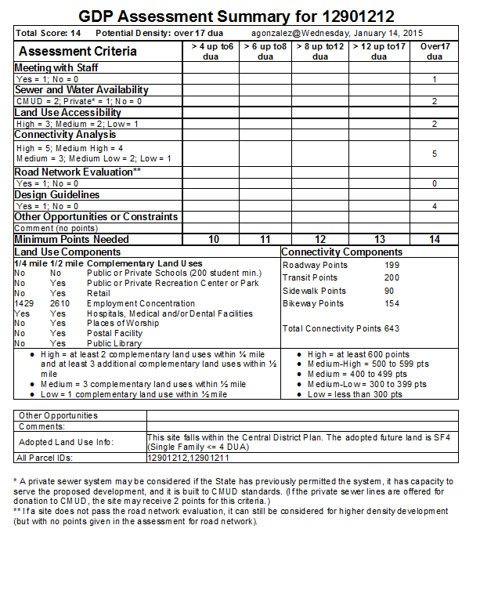

Other Land Use Considerations
- The parcels on the north side of McClintock Rd. are adjacent to the Plaza-Midwood Pedestrian Overlay District. The site on the south side of McClintock is one parcel over from the Pedestrian Overlay District.

Plan Consistency
- The petition to rezone from R-5, Residential Single Family to UR-2(CD) is consistent with the single family land use as per the Central District Plan (1993). The increase in density from 4 DUA can be considered after applying the General Development Policies (GDP). The revised site plan with single family units appears to be in context with the surrounding single-family neighborhood.

